Lab sheet 7

IT24101376

01

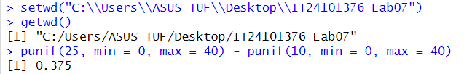

02



03.

i



ii

